Practical-1

Aim: To Install XAMPP Server.

XAMPP is a free and open-source cross-platform web server solution stack package developed by Apache Friends. It consists of Apache HTTP Server, MariaDB (formerly MySQL), and interpreters for scripts written in PHP and Perl. XAMPP is primarily used to set up a local server environment on various operating systems for testing and development

Installation steps:

1. Access the XAMPP Website:

• Search for XAMPP in your browser.

• Click on the first link, which should be <https://www.apachefriends.org>.

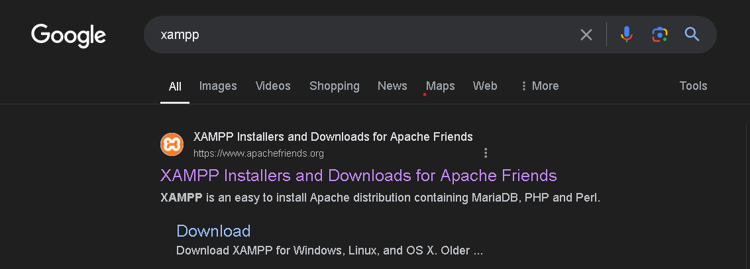

1. Download XAMPP:

• Choose the appropriate version for your operating system.

• For Windows users, click on the download link for XAMPP for Windows. 

1. Run the Installer:

• After downloading, launch the installer.

• If you encounter a User Account Control warning, click OK to proceed.

• Follow the default setup steps provided in the installer window.



1. Initial Setup:

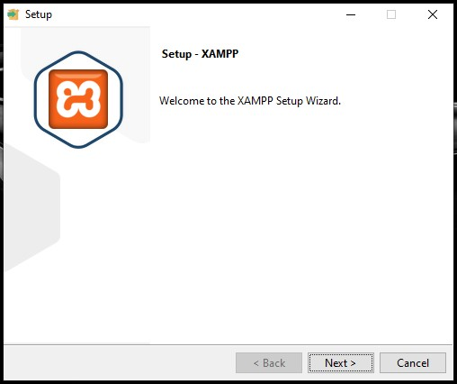

1. Select Components:

• Ensure all components are checked in the selection window.

• Click "Next" to continue. Tick all the boxes in the following pop up and click Next>.

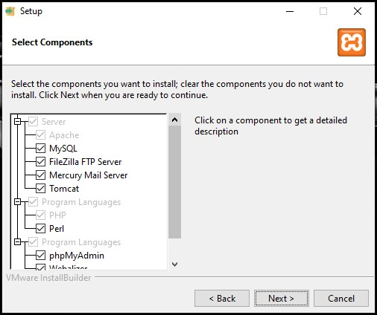

1. Choose Installation Directory:

• Click on the folder icon to choose the installation directory.

• After selecting the directory, click "Next".

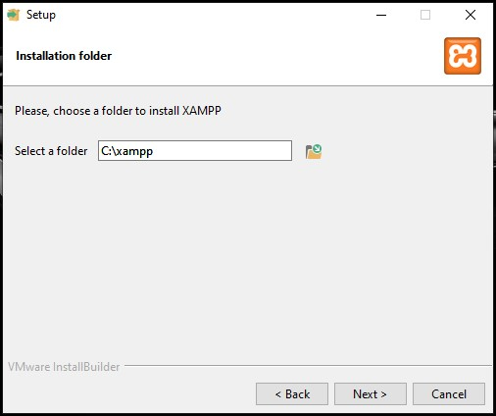

1. Select Language:

• From the drop-down menu, select your preferred language.

• Click "Next" to proceed.

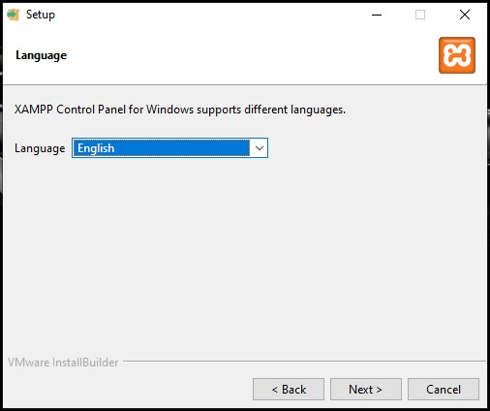

1. Begin Installing XAMPP: XAMPP will begin to install the files in the selected folder when clicked on Next> on the Ready to Install window.

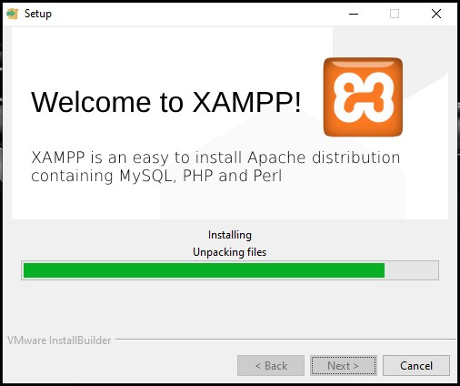

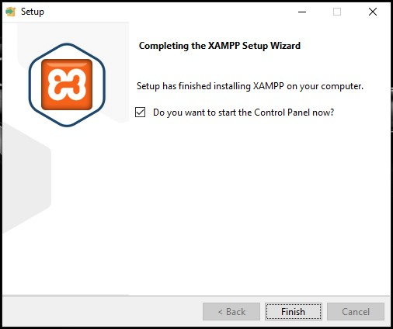

1. After installation is complete, open the XAMPP Control Panel and click on START in front of Apache and MySQL.

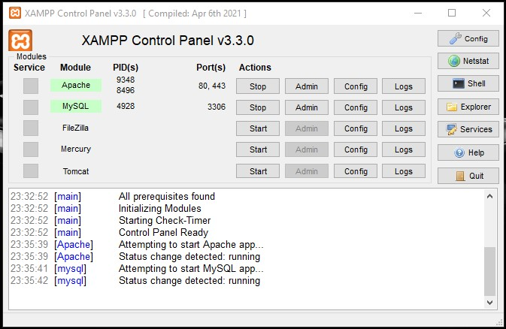

1. Open your browser and search for localhost.

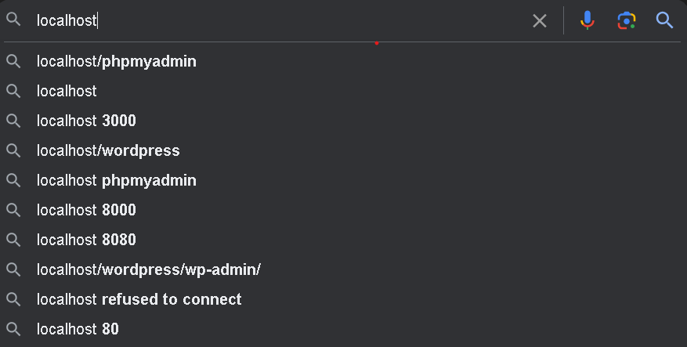

Now click on phpMyAdmin.

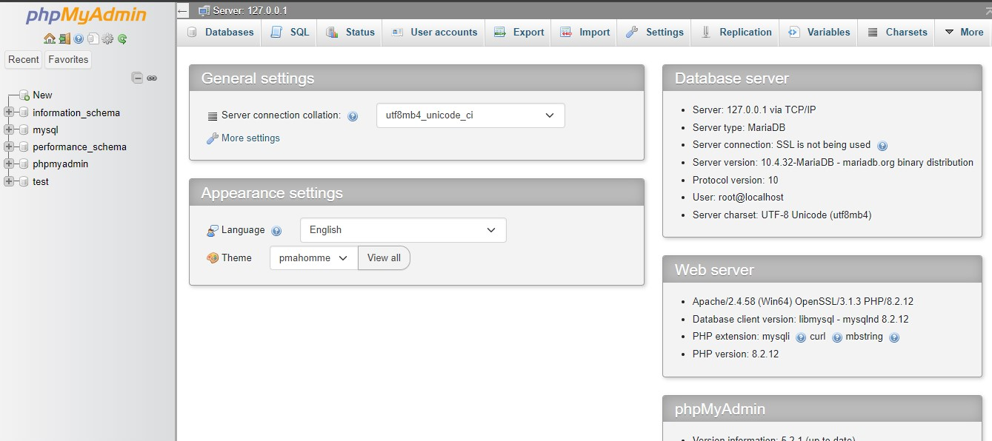

XAMPP Server is successfully installed.